TMSS GRAND HEALTH SECTOR WEBSITE UPDATE REQUIREMENTS

Audit & Monitoring

Overview:

TMSS Grand Health Sector has an internal audit & monitoring department under the Deputy Executive Director-2, TMSS. TMSS Grand Health Sector Audit & Monitoring Department formed in 17June, 2011. Audit are performed to ascertain the validity and reliability of information, also to provide an assessment of a system’s internal control, The goal is to express an opinion of the person/ organization/system (etc) in question, under evaluation based on work done on a test basis.

Activities:
- Audit, Short term Audit, Superficially Audit.
- Monitoring, Surprise Monitoring.
- Management Audit.
- Surprise Cash visit.
- Investigation.
- Inventory.
- Evaluation.

Management:
Name & Designation | Contact No | E-mail Address | Picture
Md. AI Amin  Chief (A&M) TGHS | 01714048326 | audit.monitoring.ths.tmss@ gmail.com  camthss77@gmail.com | 
Md. Kamruzzaman  Senior Officer (A&M) TGHS | 01712743842 | mdkamruzzaman46655@  gmail.com | 
Md. Mydul Islam  Computer operator (A&M) TGHS | 01737896695 | mydulcomputer@gmail.com | 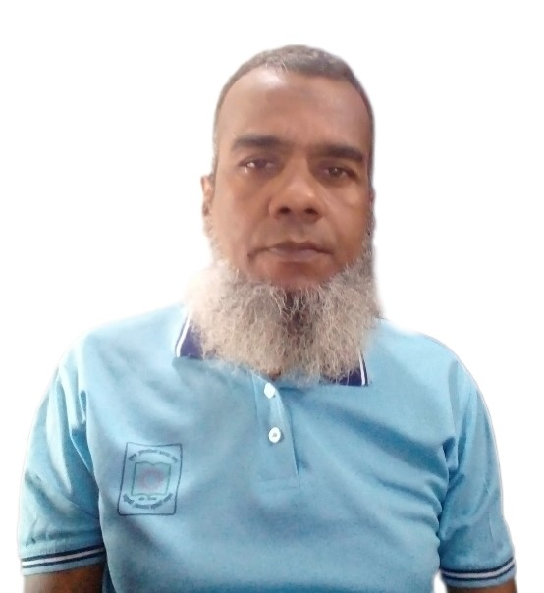

Name | Contact no | E-mail add | Picture
Tawhidur Rahman Chowdhury  Officer (A&M) TGHS | 01716762277 | towhid.bd11@gmail.com | 
Mst. Rebeka Sultana  Office Assistant (A&M) TGHS | 01703427780 |  | 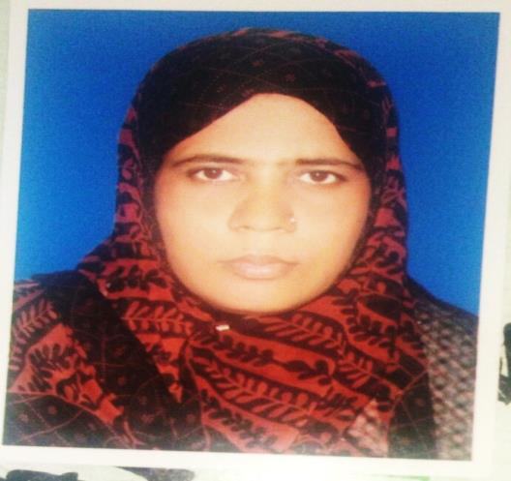

Contact Person:
Name | Designation | Contact no | E-mail add | Picture
Md. AI Amin | Chief (A&M) TGHS | 01714048326 | audit.monitoring.ths.tmss@gmail.com  camthss77@gmail.com

